**Cloud Computing Project Report**

**Executive Summary**

This project focused on developing a highly scalable and efficient data processing pipeline using AWS services, including S3, Glue, Athena, and QuickSight. The pipeline was designed to handle large datasets, transforming raw data into structured formats, performing complex queries, and delivering results through interactive visualizations. The implementation led to significant improvements in data accessibility, processing time, and decision-making efficiency. The pipeline's scalability ensured it could meet increasing data demands while maintaining cost-effectiveness, leveraging AWS's pay-as-you-go pricing model.

**Introduction**

In today’s data-driven world, businesses need to process and analyze large datasets quickly and accurately. This project utilized AWS services to build a data processing pipeline that transforms raw data into actionable insights, enabling precise and rapid decision-making. AWS S3 was used for scalable and secure data storage, AWS Glue for efficient ETL operations, Athena for serverless querying, and QuickSight for creating interactive dashboards.

**Project Setup: AWS Account and IAM Configuration**

Setting up an AWS account and configuring IAM roles and permissions was the first step. This ensured secure and controlled access to AWS resources, providing a strong foundation for building a scalable and efficient data processing pipeline.

1. **Data Storage with AWS S3**

An S3 bucket was created to store the project dataset, "musicdata.csv," containing **3,008 records**. The dataset was uploaded and organized within the S3 bucket, ensuring secure and compliant data management.

Dataset available through Object URL: [**https://projectbucket-lydia.s3.eu-north-1.amazonaws.com/source/MusicData.csv**](https://projectbucket-lydia.s3.eu-north-1.amazonaws.com/source/MusicData.csv).

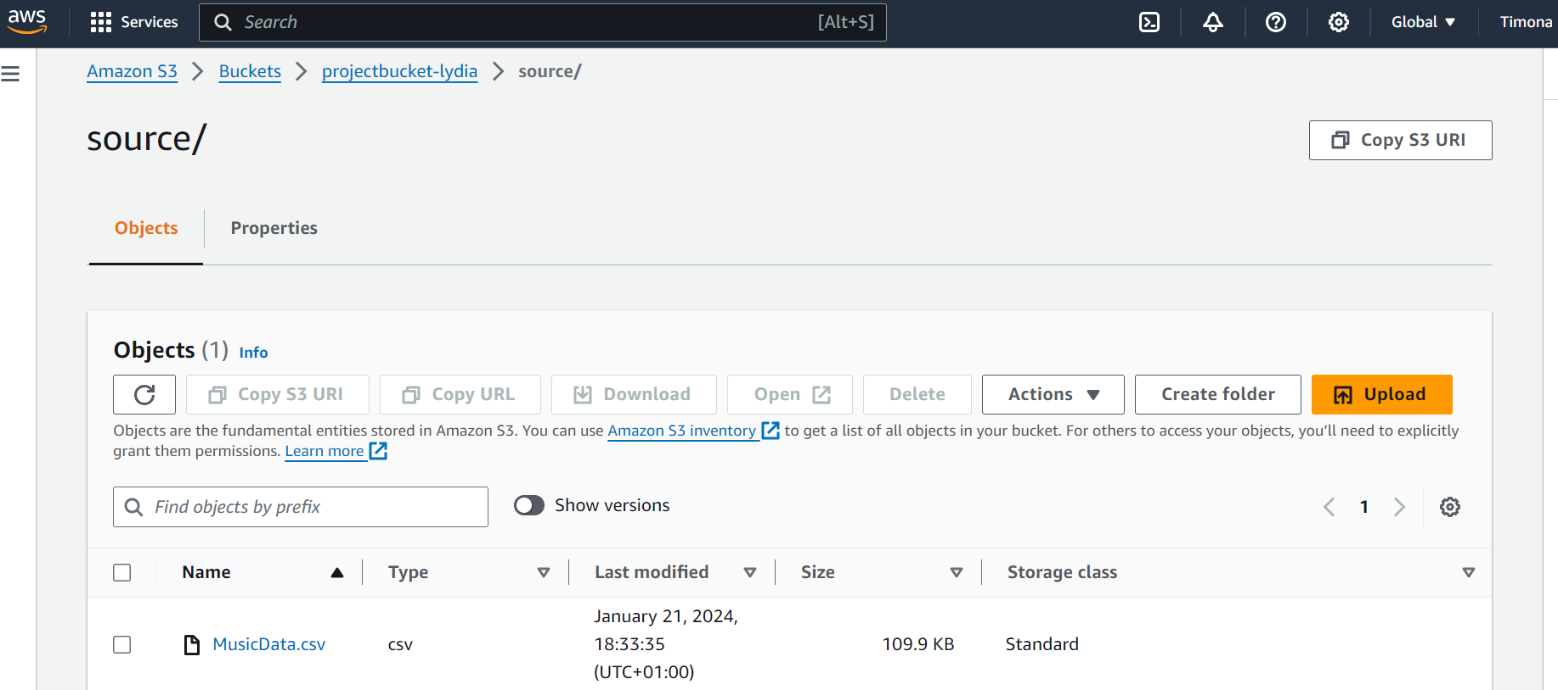

1. **AWS Glue: Data Cataloging and ETL**

**Configuring AWS Glue**

AWS Glue is a fully managed ETL (Extract, Transform, Load) service that simplifies and automates the process of preparing data for analysis. In this project, AWS Glue was a critical component, automating the data cataloging process and facilitating the transformation of raw data into a format optimized for analysis.

The first step in utilizing AWS Glue was configuring the service to integrate seamlessly with the existing AWS S3 storage and Athena query services. The Glue Data Catalog was set up to act as a centralized metadata repository, where it automatically cataloged the dataset stored in S3. This integration allowed the data to be quickly and efficiently queried using Athena without requiring manual schema definitions.

**Running a Glue Crawler**

To begin the ETL process, a Glue Crawler was created and configured to scan the S3 bucket where the music dataset, "musicdata.csv," was stored. The Crawler’s role was to inspect the data, infer the schema, and populate the Glue Data Catalog with metadata that described the structure and types of data found within the dataset. This process was crucial because it ensured that the dataset was well-organized and that its schema was accurately represented in the Glue Data Catalog, making it readily available for subsequent querying and analysis in Athena.

**ETL Jobs in AWS Glue**

After cataloging, the next step involved setting up ETL jobs in AWS Glue. The primary function of these jobs was to transform the raw data from its original format into a format that was optimized for analysis. For this project, the ETL process involved several key transformations:

1. **Data Source Specification**: The ETL job was configured to extract data from "musicdata.csv" stored in the S3 bucket. This ensured that the process began with the most accurate and updated version of the dataset.
2. **Schema Transformation**: The dataset initially contained columns with inconsistent data types, which could hinder analysis. The ETL job applied specific transformations:
   * **Format** and **Metric** columns were retained as string data types to preserve their textual information.
   * **Year** and **Number of Records** columns were converted to integer data types, enabling numerical operations.
   * The **Value (Actual)** column was converted to a float data type to facilitate calculations and statistical analysis.
3. **Output Configuration**: The transformed data was then saved in Parquet format. Parquet is a columnar storage file format optimized for analytical queries. By choosing Parquet, the project benefited from faster query performance and reduced storage costs due to its efficient compression and encoding schemes.

**Before Transformation:**

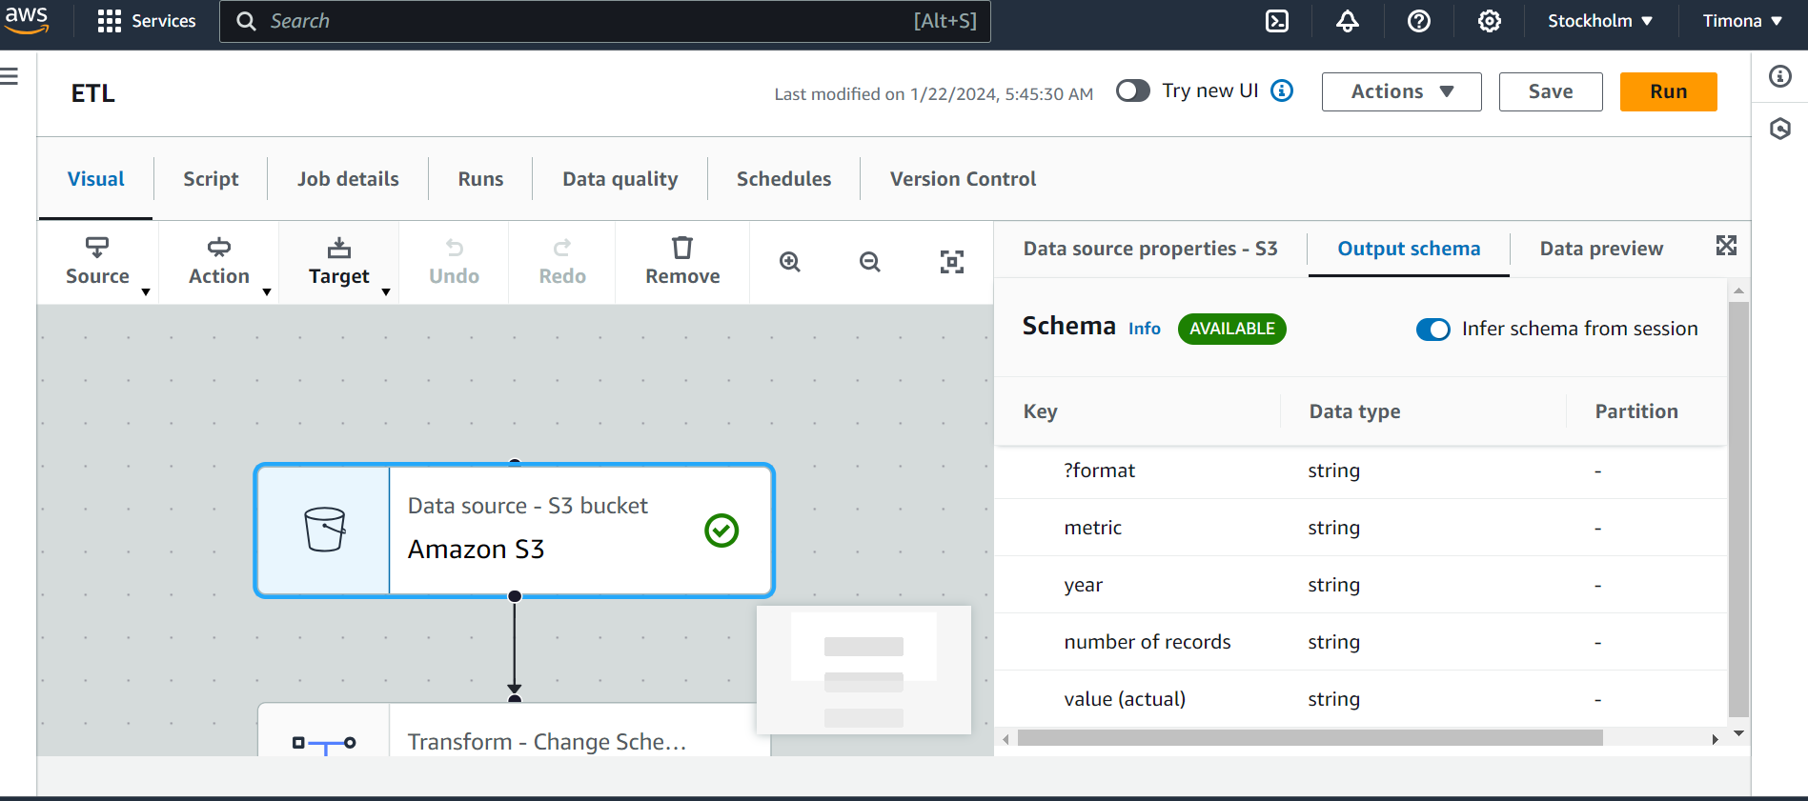

**After Transformation:**

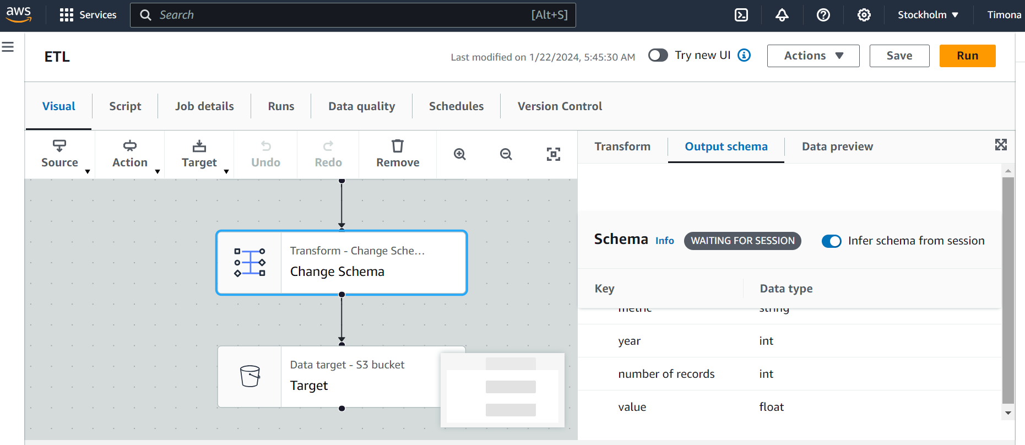

1. **Data Catalog Integration**

Once the ETL process was completed, the transformed dataset was automatically added to the AWS Glue Data Catalog. This integration made the data immediately queryable via AWS Athena, significantly streamlining the workflow by eliminating the need for additional configuration steps. The creation of a new table in the Data Catalog allowed the dataset to be organized and accessed efficiently, supporting complex queries and data analysis.

1. **Partitioning for Performance**

To further optimize performance, the data was partitioned by the **Year** column. Partitioning is a crucial strategy in big data processing, as it enables the query engine (Athena, in this case) to scan only the relevant portions of the dataset, significantly reducing the amount of data processed during each query. This approach not only improved query performance but also reduced costs associated with data scanning.

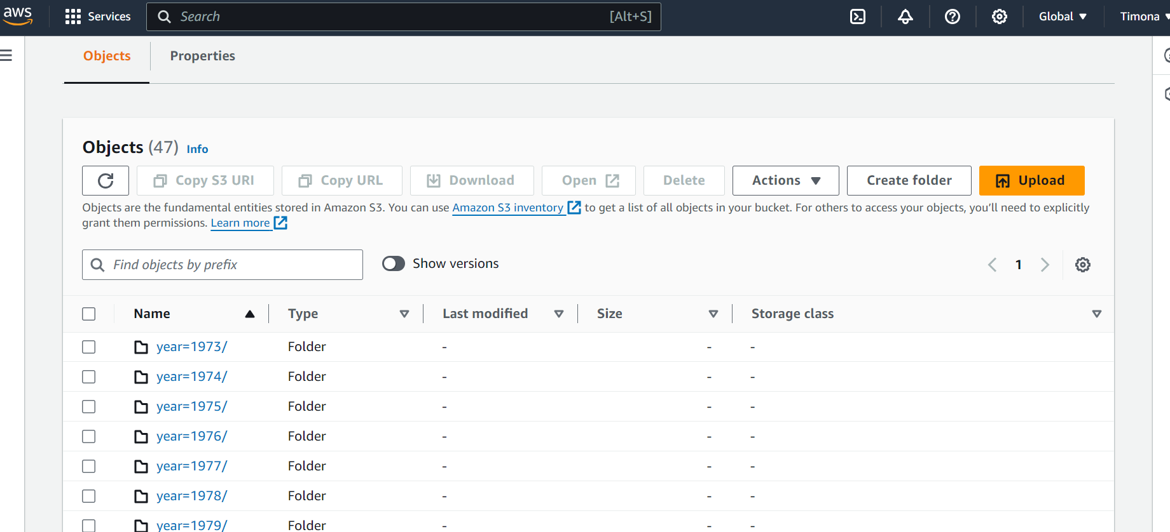

1. **Target Storage and Query Preparation**

The final step in the ETL process involved storing the transformed and partitioned data back into the S3 bucket. The data, now in Parquet format and properly partitioned, was ready for efficient querying and analysis using Athena.

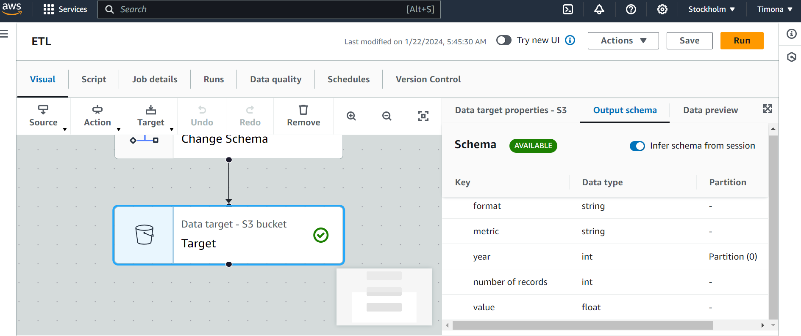

**Conclusion**

The use of AWS Glue in this project was instrumental in automating and optimizing the ETL process. By leveraging Glue’s capabilities, the project achieved a high level of data organization, transformation, and readiness for analysis, ensuring that the data was both accessible and cost-efficient. This setup not only met the project’s objectives but also provided a scalable solution for handling increasingly complex datasets in the future.

1. **Data Querying with AWS Athena**

AWS Athena is a powerful, serverless query service that allows users to analyze large datasets directly stored in Amazon S3 using standard SQL. One of the main advantages of Athena is that it does not require any infrastructure to manage; you simply point Athena at your data in S3, define your schema, and start querying. This makes it an ideal choice for data analysis in scenarios where scalability, ease of use, and cost-efficiency are critical.

**Configuring Athena for the Project**

In this project, AWS Athena was configured to work seamlessly with the AWS Glue Data Catalog. The Glue Data Catalog acted as the central metadata repository, holding all necessary schema definitions for the datasets stored in S3. By integrating Athena with the Glue Data Catalog, the project could leverage Athena's ability to understand and query the data without the need for manual schema input.

**Steps to configure Athena:**

1. **Connection to Data Catalog**: When AWS Athena was opened in the AWS Management Console, it automatically recognized the Glue Data Catalog as the default metadata store. This integration ensured that all data stored in S3 and cataloged by Glue was immediately available for querying.
2. **Permissions**: Proper IAM roles and permissions were configured to ensure that Athena had the required access to both the Glue Data Catalog and the S3 buckets where the data was stored. This setup was crucial to maintaining the security and integrity of the data while allowing seamless querying.
3. **Database and Table Selection**: Within the Athena console, the appropriate database corresponding to the Glue Data Catalog was selected. This allowed easy access to the tables created by the Glue Crawler, ensuring that the data was query-ready.

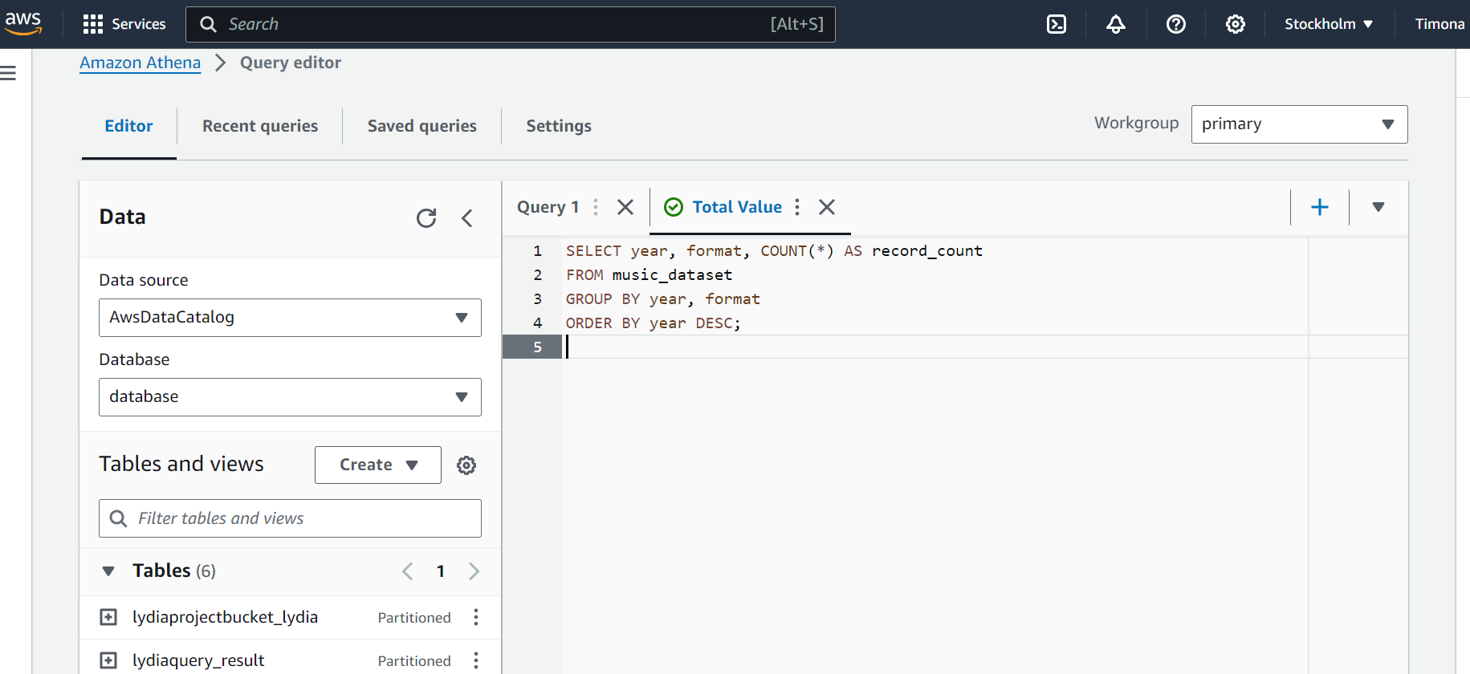

**Query Execution and Optimization**

With Athena configured and connected to the Glue Data Catalog, the next step involved writing and executing SQL queries to analyze the data. The focus was on extracting meaningful insights from the transformed dataset stored in Parquet format within the S3 bucket.

**Key aspects of the query process:**

* **SQL Query Writing**: The SQL queries were designed to analyze trends, summarize data, and extract insights based on the project’s objectives. For instance, queries were written to summarize music records by year and format, providing a clear view of trends over time.
* **Performance Optimization**: Athena charges are based on the amount of data scanned by each query. To optimize costs and improve query performance, several strategies were employed:
  + **Use of Parquet Format**: The dataset was stored in Parquet format, which is highly efficient for querying large datasets. Parquet’s columnar storage significantly reduced the amount of data scanned during each query, leading to faster execution times and lower costs.
  + **Data Partitioning**: The dataset was partitioned by the Year column. This allowed Athena to scan only the relevant partitions when queries were run, further reducing the data scanned and optimizing query performance.
  + **Query Refinement**: SQL queries were refined to minimize unnecessary data processing. This included selecting only the necessary columns and filtering data early in the query process to reduce the load on Athena.

The screenshot provided shows a specific SQL query used in this project. The query counts records grouped by year and format, helping to identify trends in the data. This kind of query is fundamental in extracting insights that drive decision-making.

**Data Output and Storage**

After executing queries, Athena provides several options for managing and storing the query results:

* **Immediate Results Display**: The results of each query were displayed directly in the Athena console, allowing for immediate analysis and verification.
* **Saving Results to S3**: For further analysis and auditing, the output from queries was saved back to an S3 bucket. This practice ensured that all query results were securely stored and easily accessible for future reference or additional processing.

The results were stored in a designated S3 bucket, ensuring that all outputs were organized and could be retrieved as needed.

**Benefits of Using AWS Athena**

The use of AWS Athena in this project brought several key benefits:

* **Cost Efficiency**: By charging only for the data scanned, Athena offered a highly cost-effective solution for querying large datasets, especially when combined with the optimizations applied (Parquet format and partitioning).
* **Scalability**: Athena’s serverless architecture automatically scaled to meet the computational demands of each query, ensuring that even large datasets were processed efficiently without manual intervention.
* **Ease of Use**: The seamless integration with AWS Glue Data Catalog and the familiar SQL interface made Athena easy to use, even for complex queries, without requiring extensive setup or maintenance.

**Conclusion**

The integration of AWS Athena into the data processing pipeline provided a robust and efficient means of querying and analyzing the dataset. The combination of serverless querying, cost-effective processing, and powerful SQL capabilities made Athena an invaluable tool in achieving the project’s objectives. Through the strategic use of data formats and partitioning, the project was able to minimize costs and maximize performance, ensuring that insights could be derived quickly and efficiently.

1. **Data Visualization with AWS QuickSight**

AWS QuickSight is a cloud-based business intelligence service that allows users to create interactive visualizations and dashboards. It integrates seamlessly with other AWS services, such as S3 and Athena, enabling real-time data visualization and analysis directly from cloud-stored data.

**Setup and Data Integration**

For this project, QuickSight was set up to visualize data processed using S3, Glue, and Athena. The setup involved connecting QuickSight to these data sources, preparing the data, and configuring visualizations that aligned with the project’s objectives. The intuitive interface of QuickSight made it accessible to users with varying technical expertise.

**Creating Visualizations and Dashboards**

QuickSight was used to create various visualizations, including bar charts, line graphs, and pie charts, which provided insights into trends within the dataset. Interactive dashboards were developed, featuring filters, drill-down capabilities, and cross-visualization interactions, enabling in-depth data exploration.

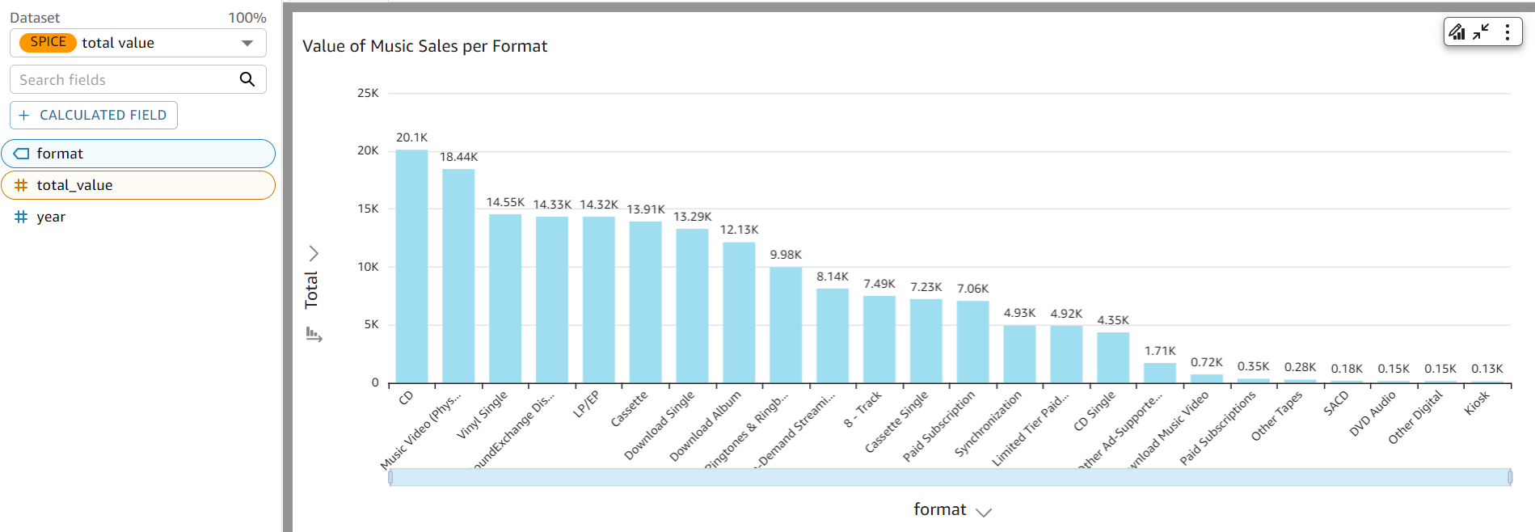

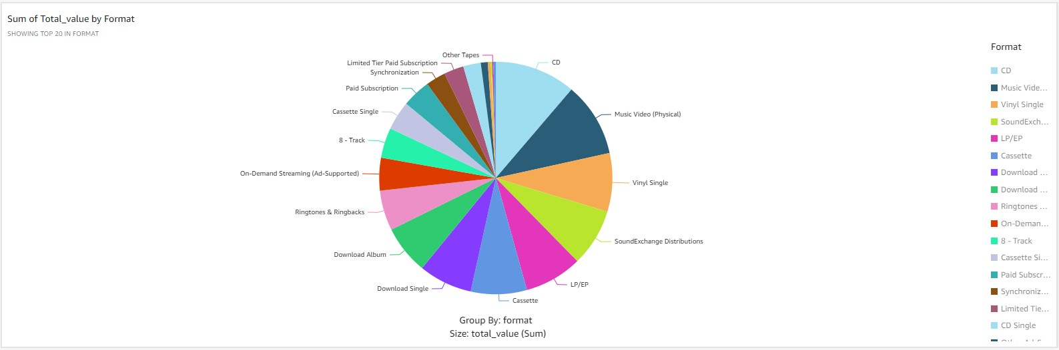

**Conclusion**

AWS QuickSight played a vital role in this project, transforming data into actionable insights through dynamic and interactive visualizations. Its seamless integration with other AWS services and user-friendly interface made it a key tool in the data processing pipeline.

**Security and Compliance**

Robust security measures were implemented throughout the project, including IAM roles, S3 bucket policies, and encryption for data at rest and in transit. Compliance with data governance and privacy laws was ensured, with continuous monitoring to maintain security standards.

**Cost Management**

Cost-effectiveness was a key focus, with strategies such as S3 lifecycle policies, data partitioning, and the use of Parquet format to reduce costs. Continuous monitoring through AWS Cost Explorer and budget alerts helped manage expenses efficiently.

**Monitoring and Maintenance**

The pipeline’s operational integrity was maintained through tools like AWS CloudWatch for resource monitoring and AWS Glue and Athena monitoring for job and query efficiency. Regular audits and updates ensured the pipeline remained secure, efficient, and cost-effective.

**Challenges and Solutions**

Several challenges were encountered, including handling large, complex datasets and ensuring consistent data quality. These were addressed through data partitioning, query optimization, and automated data quality checks.

**Results and Evaluation**

The project met its objectives, delivering a scalable, cost-effective, and secure data processing pipeline. The integration of AWS services enabled real-time data analysis and insightful visualizations, significantly enhancing data-driven decision-making.

**Lessons Learned**

Key lessons included the importance of designing scalable pipelines, continuous cost management, and the need for critical data quality checks to ensure reliable analytics.